# Upload Relevant Documents

## Upload Steps

1. Click on the checkbox of upload relevant documents.

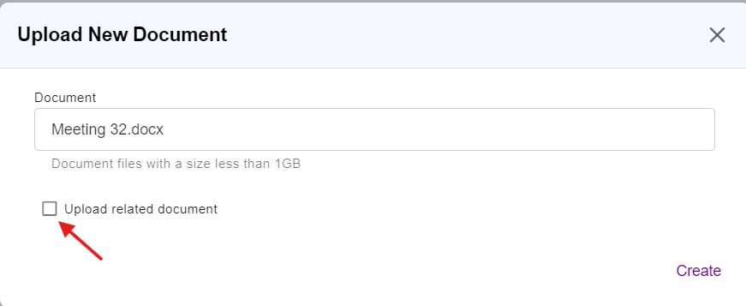

**1**

1. The text content of the above uploaded main document (e.g. Meeting 32.docx) will be analyzed to detect the list of relevant documents based on the rules explained in Section 1.2. Then, the list of detected relevant documents will be displayed.
2. The user can also add the relevant documents manually.
3. Click on Create button to finish the creation/upload of new documents.

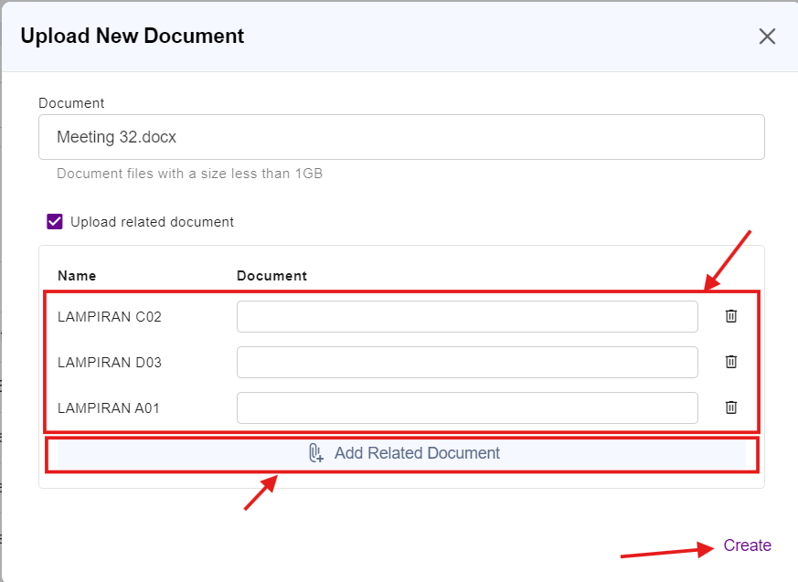

**4**

**3**

**2**

## Relevant Document Words Detection

The detection rules/patterns of possible relevant document words from the text content of the main documents are shown at table below.

**Notes:**

*x* – uppercase letter (A-Z)

*y* – digits/number (0-9)

|  |  |
| --- | --- |
| No. | Word Detection Rules/Patterns |
| 1. | **Rules:** LAMPIRAN *xyy*  **Examples:** LAMPIRAN B04, LAMPIRAN A31 |
| 2. | **Rules:** APPENDIX *xyy*  **Examples:** APPENDIX C18, APPENDIX D02 |
| 3. | **Rules:** *xyy*-*xxyy*  **Examples:** B03-KA01, B19-LA03 |

Table 1.1 Relevant Document Word Detection Rules